 **COMSATS University Islamabad Lahore Campus**

**Lab Final Term – FALL 2022**

|  |  |  |  |  |  |  |  |  |  |
| --- | --- | --- | --- | --- | --- | --- | --- | --- | --- |
| Course Title: | Mobile App Development | | | | Course Code: | | CSC 303 | Credit Hours: | 3(2,1) |
| Course Instructor/s: | Akhzar Nazir | | | | Program Name: | | BS CS, BS SE | | |
| Semester: | 5th 6th 7th | Batch: | FA 20/19 | Section: | A,B,C | | Date: | 10-01-2023 | |
| **Time Allowed:** | **180 Minutes** | | | | **Maximum Marks:** | | | **100** | |
| Student’s Name: |  | | | | Reg. No. |  | | | |
| **Important Instructions / Guidelines:**   * Avoid overwriting and cutting. * Read the questions carefully. | | | | | | | | | |

**Download JSON from the given link and import it into your firebase realtime database, connect firebase realtime database with your app and show data as describe in given Screen shots**

**JSON link**

[**https://drive.google.com/file/d/1v0uBcf6Qdyz8VedTQM7gV-YRBE46UEmS/view?usp=share_link**](https://drive.google.com/file/d/1v0uBcf6Qdyz8VedTQM7gV-YRBE46UEmS/view?usp=share_link)

**Marks distribution will be like this**

1. Designing of the Screen – **[25 Marks]**
2. Connection of your App with firebase and fetch data according to the requirements - **[50 Marks]**
3. Save data into your local database - **[25 Marks]**

Note: Every student should pick only 1 screen

[Divide your roll number by 10 and find remainder, for example if your roll number is 79 divide it by 10 remainder is 9, so your task is screen 9, In case if your roll number is 10 remainder will be 0 and your task is screen 0]

**Screen # 0**

Design the following screen, By clicking on Read Quran Quran data from JSON will be downloaded and saved to local DB, and will show in FlatList

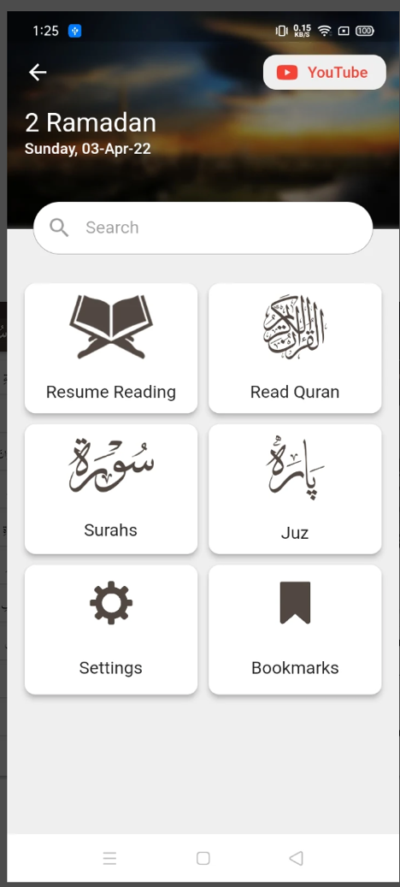

Screen # 1 Design following screen, when user click on Surah Fatiha, All Ayat from Surah Fatiha will be download and saved into local DB

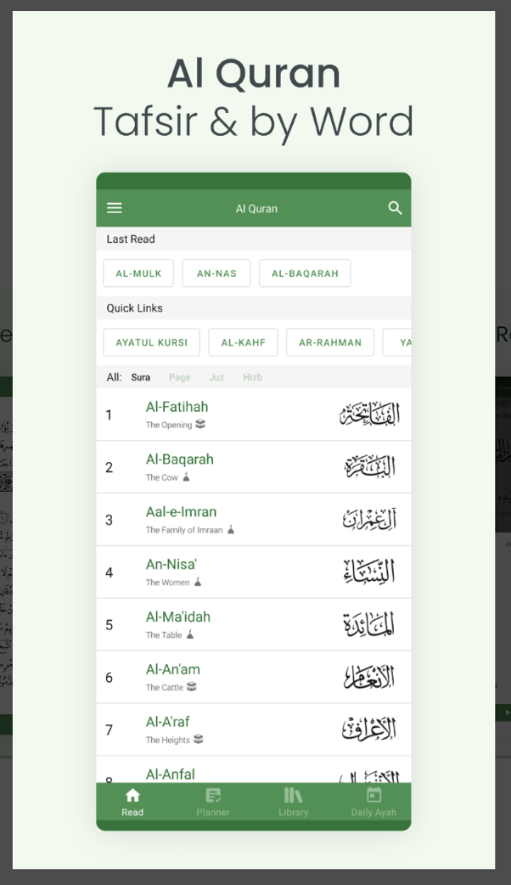

Screen # 2 Design the following screen, and write some tafaseer names instead of Hadees Books, When user tap on first tafseer, it will download all data from firebase and will show in FlatList

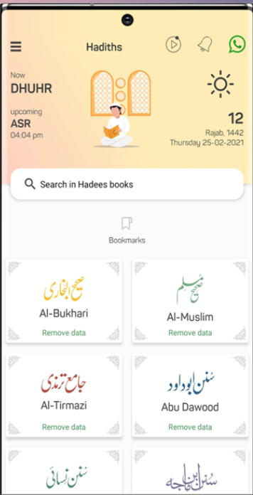

Screen # 3 Design the following Screen, When user click on any Surah, All ayats of Surah Fatiha will downloaded from firebase and save into local DB

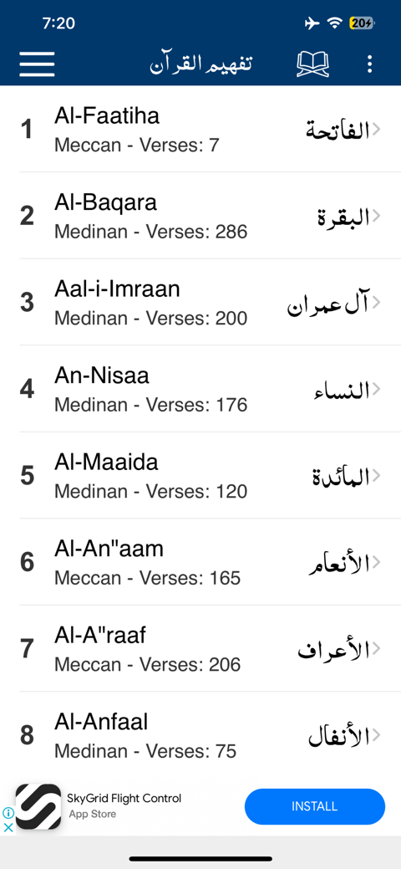

Screen # 4 Design the following screen and download data into local DB from firebase, for example when user scroll down to read 4th and 5th Ayat just 4th and 5th Ayat will be downloaded and save into local DB

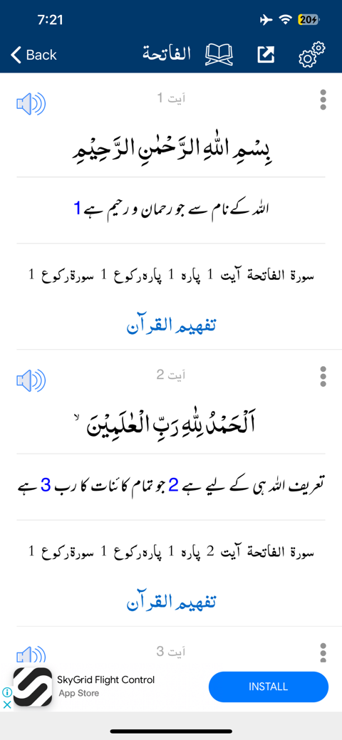

Screen # 5 Replace below Data with Surah Names and Download the Surah when user click on Download Button, After complete Download change the icon, When user tap on the Surah which is already downloaded it should show in any format

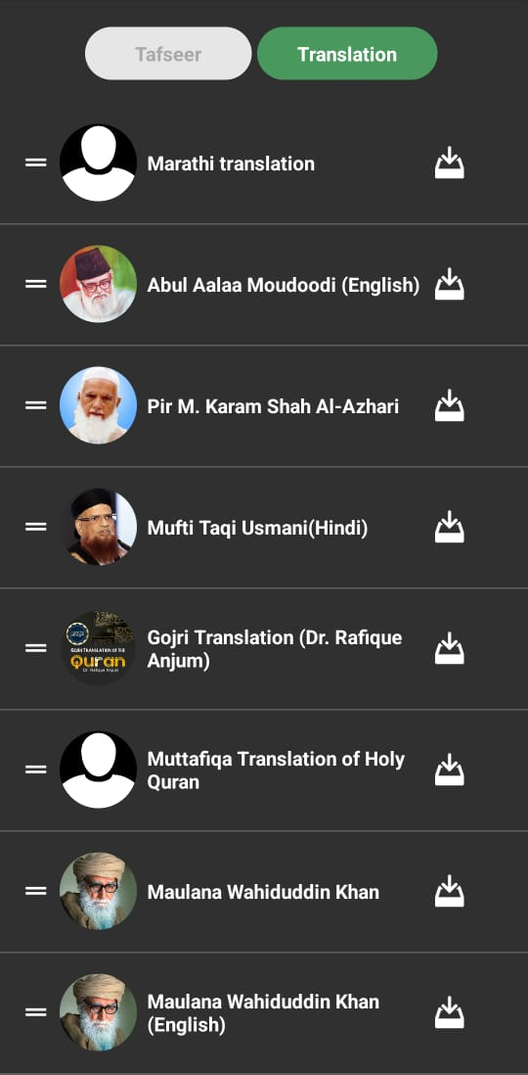

Screen # 6 Download firebase db into local DB Apply Search and highlight the Searched word [Search from firebase or search from Array]

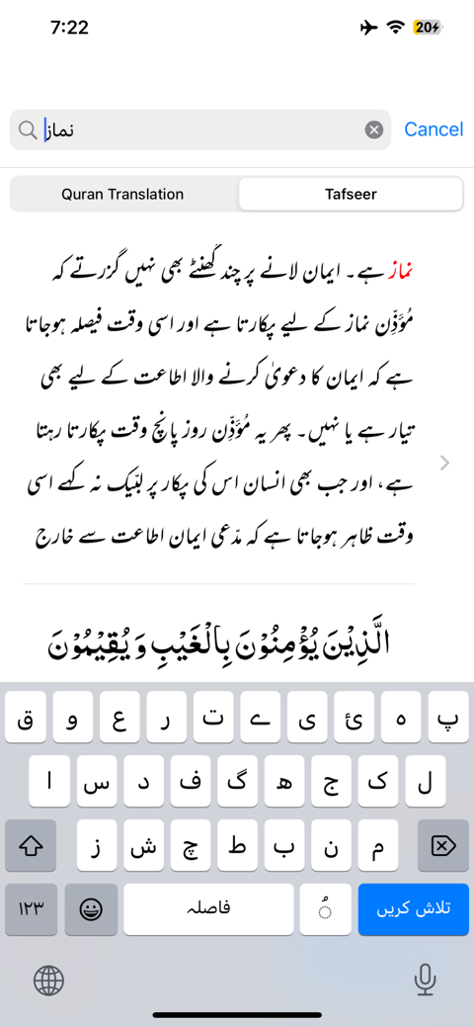

Screen # 7 Download firebase db into local DB Apply Search and highlight the Searched word [Search from firebase or search from Array]



Screen # 8 Download firebase db into local DB Apply Search and highlight the Searched word [Search from firebase or search from Array]



Screen # 9 Download firebase db into local DB Apply Search and highlight the Searched word [Search from firebase or search from Local Array]

